**AJAX**



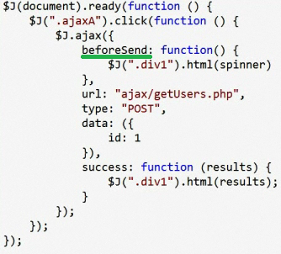

Create file in folder ajax type html and named it getUsers.ph The file will say

<?php print "hello world"; ?>

